02 · ER Diagram (Entity-Relationship Model)
Project: StaffSync — HRM System Document type: Story
Status: In Progress · Owner: Shiwani Jha

1. Purpose
The Entity-Relationship Diagram (ERD) represents the core data structure of the Human Resource Management System. It defines how the entities Employee, Manager, LeaveRequest, Attendance and Announcement relate to one another, and how those concepts are stored in MongoDB.

2. Conceptual ER Diagram
This is the logical model from the design phase.
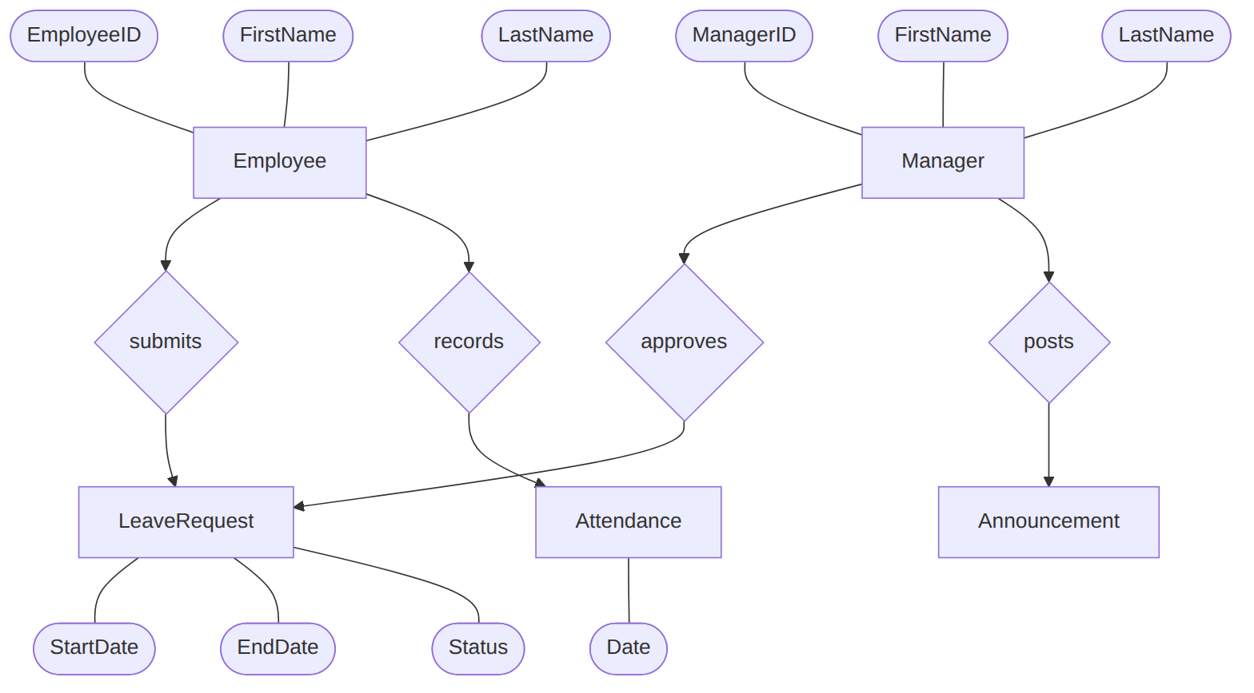

2.1 Entity explanation
Entity | Attributes | Description
Employee | EmployeeID, FirstName, LastName | A staff member. Can submit many leave requests and has daily attendance records.
Manager | ManagerID, FirstName, LastName | A supervisor who approves or rejects leave requests and posts announcements.
LeaveRequest | StartDate, EndDate, Status | A leave application submitted by an employee, decided by a manager/HR.
Attendance | Date | Daily presence record of an employee.
Announcement | Title, Body | Organization-wide news or updates posted by managers or HR.

2.2 Relationships
Relationship | Cardinality | Meaning
Employee submits LeaveRequest | 1 : N | One employee submits many leave requests
Manager approves LeaveRequest | 1 : N | One manager reviews many leave requests
Manager posts Announcement | 1 : N | One manager publishes many announcements
Employee records Attendance | 1 : N | One employee has one attendance record per day

3. Implemented Physical Model (MongoDB / Mongoose)
In the implementation, Employee and Manager are not separate collections. Both are stored in a single users collection and distinguished by the role field (admin, hr, manager, employee). This removes duplicated data and lets one login system serve every role.
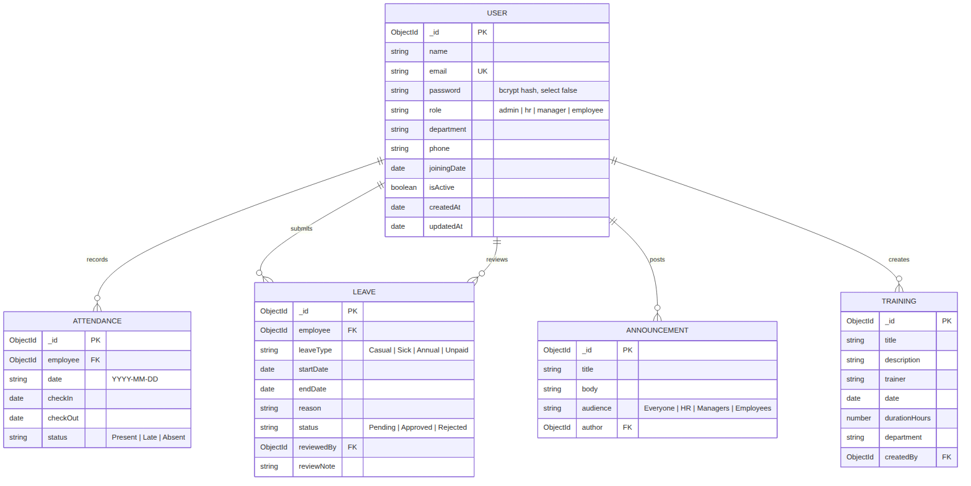

3.1 Conceptual → physical mapping
Conceptual entity | MongoDB collection | Notes
Employee | users (role = employee)
Manager | users (role = manager)
HR / Admin | users (role = hr / admin) | Additional roles
LeaveRequest | leaves | reviewedBy references the approving user
Attendance | attendances | One record per employee per date
Announcement | announcements | author references the poster
Training programs | trainings | createdBy references the creator

4. Collection Details

4.1 users
Field | Type | Rules
name | String | required, trimmed
email | String | required, unique, lowercase
password | String | required, hashed with bcrypt, excluded from queries by default
role | String | enum admin, hr, manager, employee, default employee
department | String | default General
phone | String | default empty
joiningDate | Date | default now
isActive | Boolean | default true; false = deactivated (soft delete)

4.2 attendances
Field | Type | Rules
employee | ObjectId → users | required
date | String YYYY-MM-DD | required
checkIn | Date | default now
checkOut | Date | default null
status | String | Present, Late, Absent (default Present)
Index: { employee: 1, date: 1 } is unique. A user can have only one record per day. The backend removes the legacy user_1_date_1 index on start-up.

4.3 leaves
Field | Type | Rules
employee | ObjectId → users | required
leaveType | String | Casual, Sick, Annual, Unpaid
startDate / endDate | Date | required; endDate >= startDate enforced by the API
reason | String | required
status | String | Pending (default), Approved, Rejected
reviewedBy | ObjectId → users | set when reviewed
reviewNote | String | optional comment

4.4 announcements
Field | Type | Rules
title, body | String | required
audience | String | Everyone, HR, Managers, Employees
author | ObjectId → users | required

4.5 trainings
Field | Type | Rules
title | String | required
description, trainer | String | optional
date | Date | required
durationHours | Number | min 1, default 1
department | String | default All Departments
createdBy | ObjectId → users | required

5. Leave Request Lifecycle
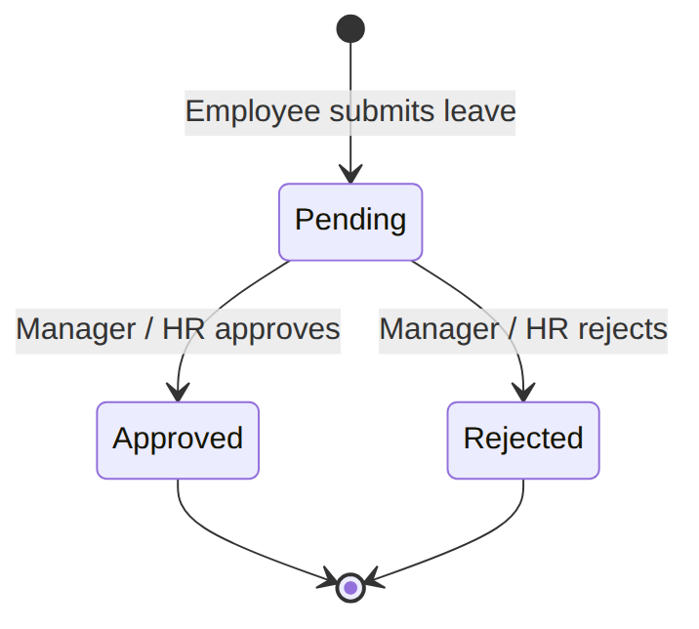

6. Data Flow Between Entities
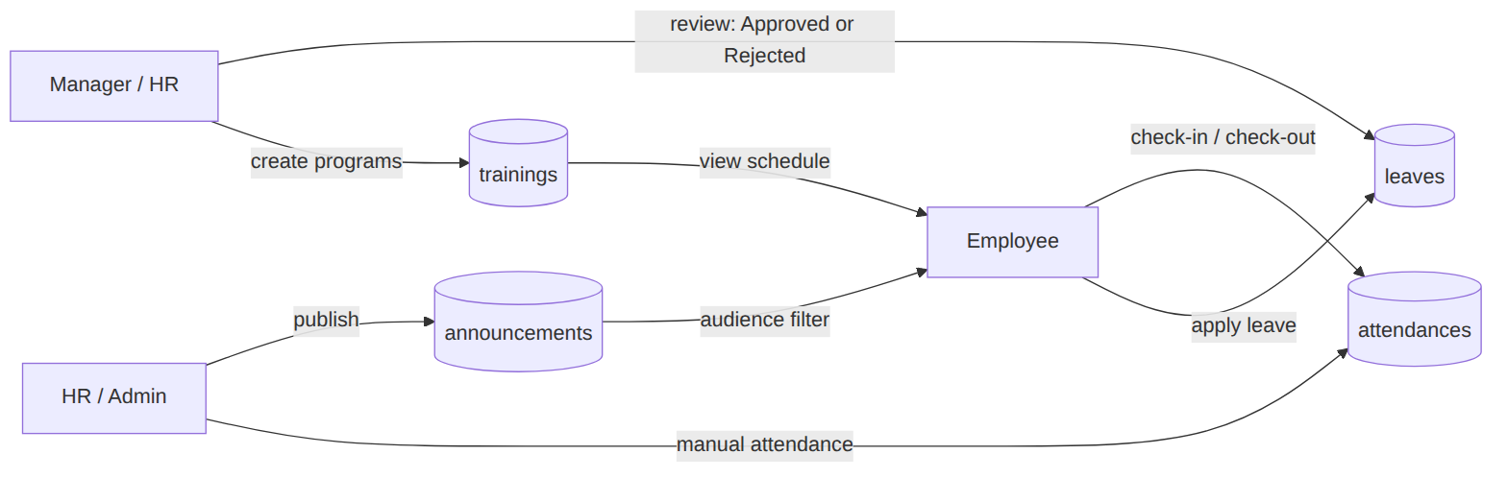

7. Referential Rules
- Foreign keys are stored as ObjectId references and resolved with Mongoose populate().
- Users are never hard-deleted, so historical leave, attendance and announcement references stay valid.
- Duplicate attendance for the same employee and date is rejected with HTTP 409.

